Name: Akanksha N Shenoy Group : 1

Roll No: 1905373 Branch: CSE

CN Lab Assignment

Questions:

1. Design a simple network by connecting two PCs and show the message exchange between the

two systems.

2. Design a network where 4 PCs named as S1, S2, S3, and S4 are connected to a hub H1 and

show the message exchange among the systems.

3. Design a network where 5 PCs named as PC-1, PC-2, PC-3, PC-4, and PC-5 are connected to

a switch S1 and show the message exchange among the systems.

4. Design a network where 3 PCs are connected to a hub H1 and 4 PCs connected to a switch S1.

Connect the hub H1 and the switch S1 and show the message exchange among the systems.

Answers:

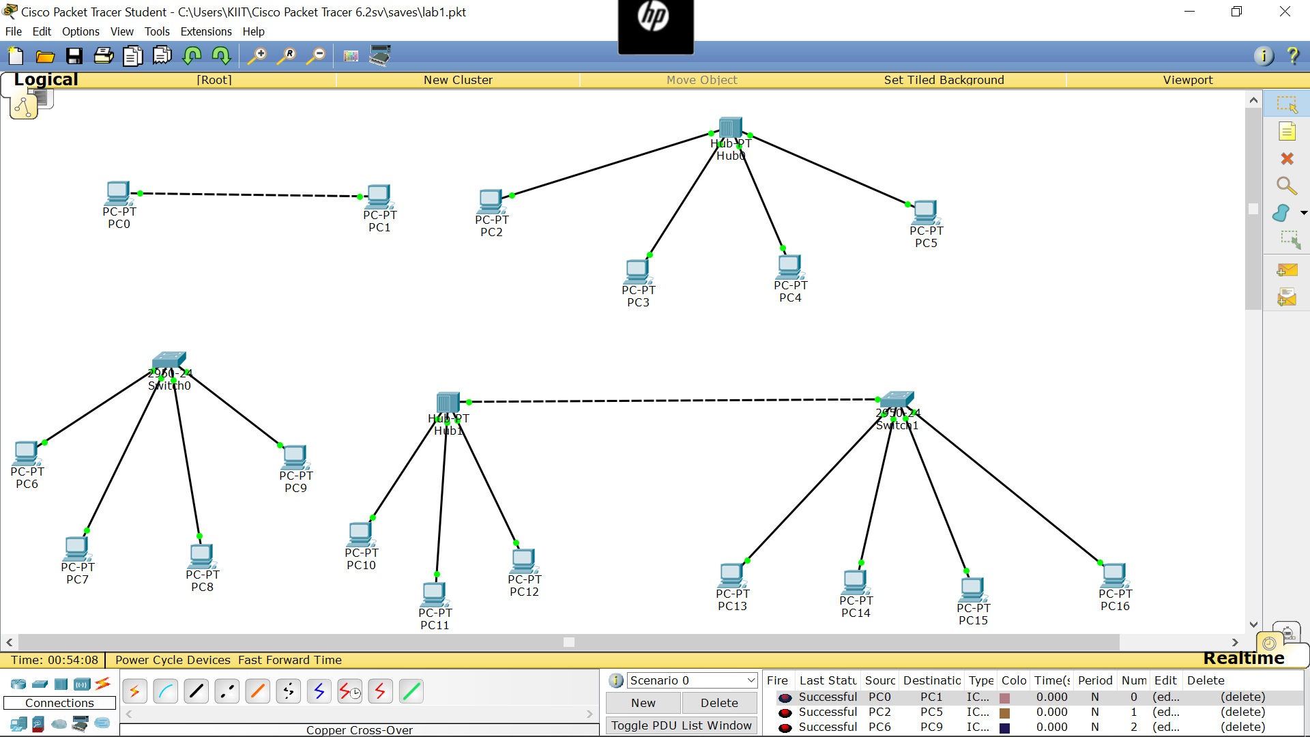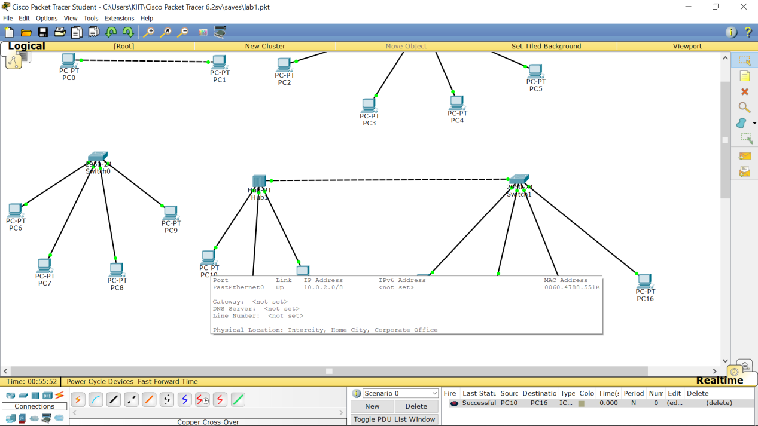

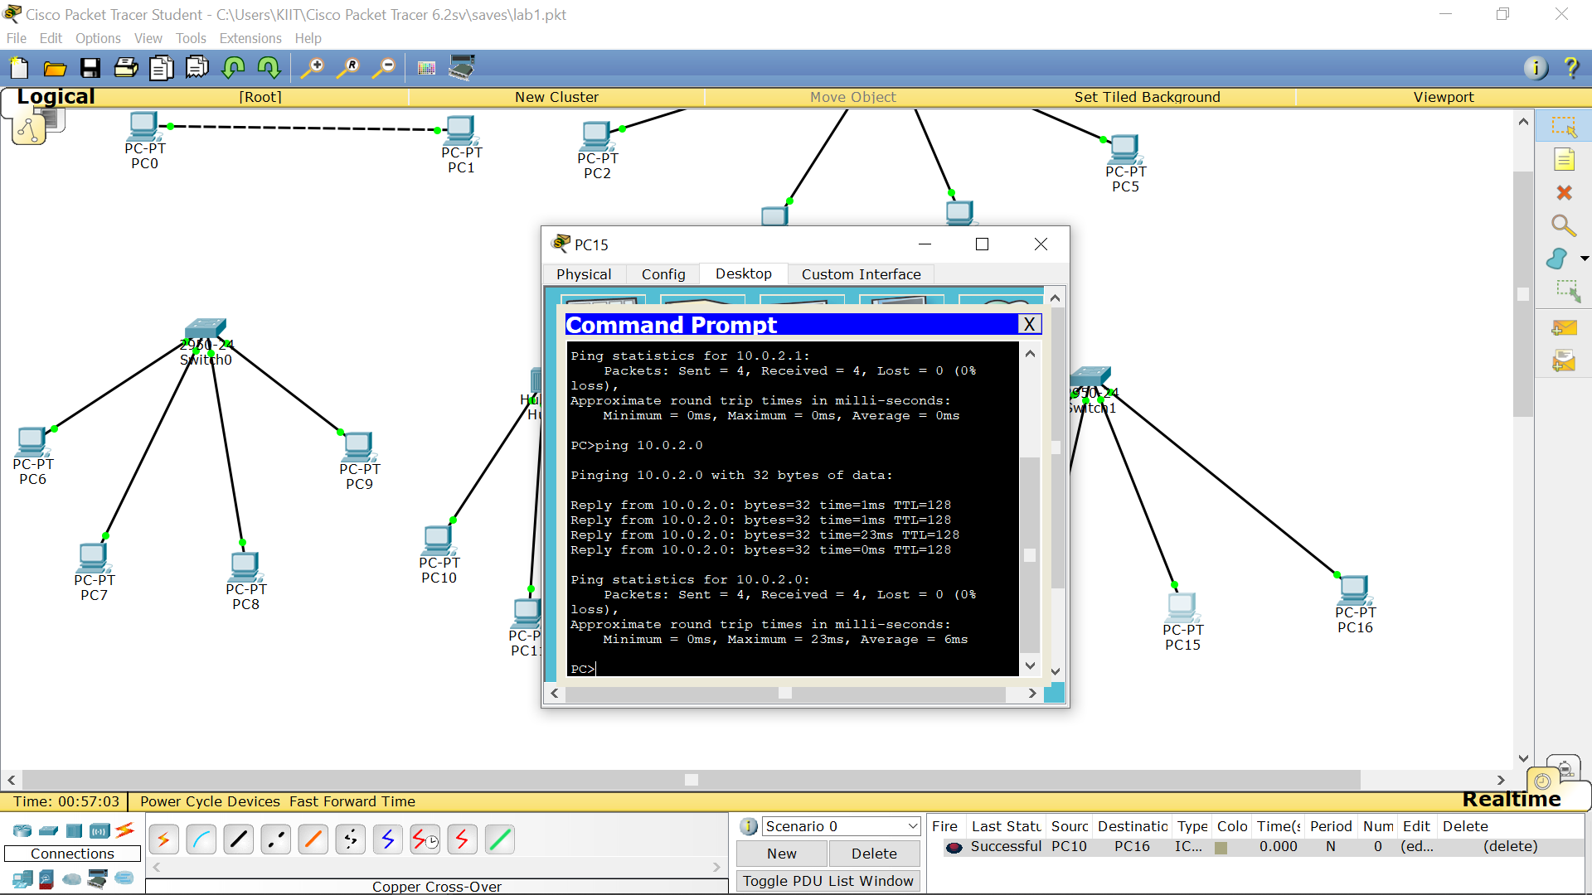

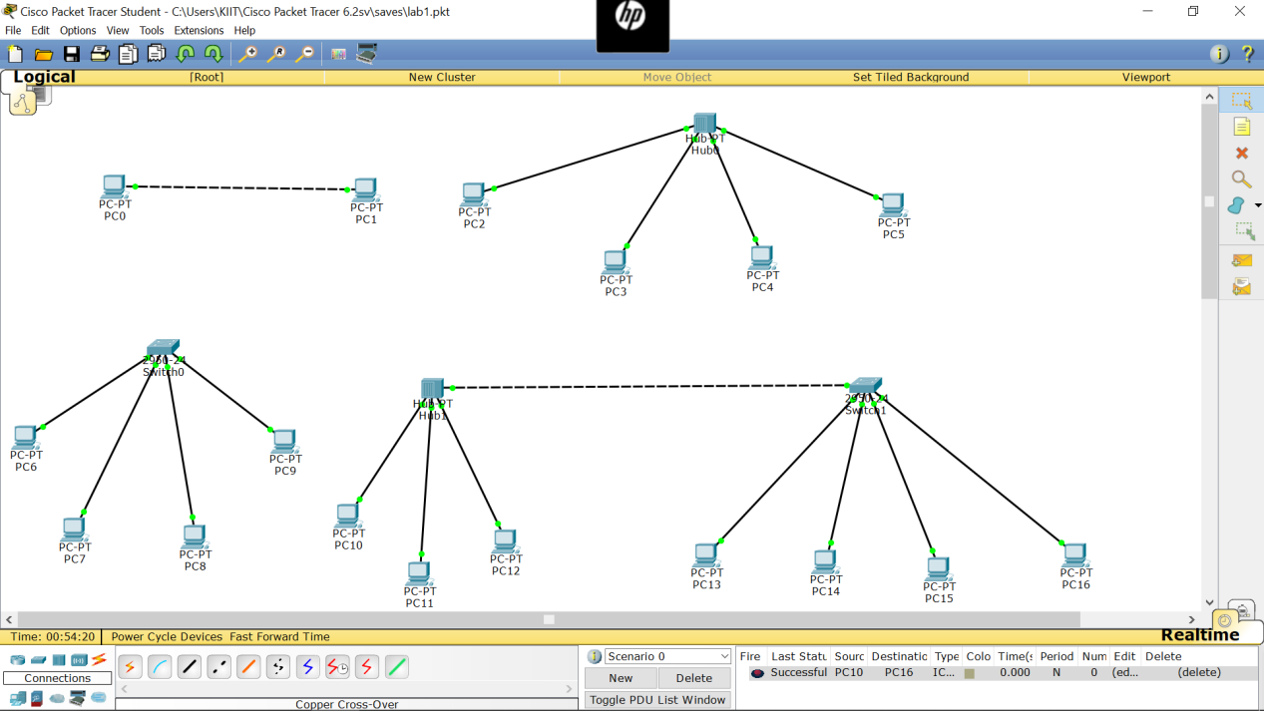

------------------------------------------------------------------------------X---------------------------------------------------------------------------------------